Farm

Booking

**Project 10 - Masterpiece**

**Developed and Documented by:**

Ahmad Omar Riahna

**March 2022**



PROJECT TECHNICAL DOCUMENTATION

PROJECT SUMMARY:

A website directed mainly to all users , the idea is to booking farms in Jordan.

PROJECT PROBLEM:

The lack of available information about the farms in jordan and the difficulty of accessing them, which requires either direct communication or communication by phone or on social media, may waste time and effort.

PROJECT OBJECTIVES:

Facilitating the booking farms, providing a this website that facilitates access to everything related to the farms in jordan by providing sufficient information about the place and location and more image for each farm.

PROJECT EXPECTED OUTPUT:

Web application designed to be user-friendly and facilitate the process of reservation for farms in jordan.

TECHNOLOGIES USED:

1. HTML/CSS/JS.
2. React Library.
3. Laravel Framwork.
4. MySQL.

REQUIREMENTS

**Stakeholders: The stakeholders of my app are divided into two types:**

1. User**:** Who can access the website and his functions are as follows:

* The user can reserve a Farm.
* The user can view farm details.
* The user can make a comment on a specific farm.
* The user can view other user’s comments.
* The user can view his/her profile information.
* The user can edit his/her profile information.

1. Admin: Who manage the farms, governorates, users, comments as well as reservations and his functions are as follow:

* Admin can add a new farm to the website.
* Admin can edit the information of existing farms.
* Admin can delete an already existing farm.
* Admin can add a new user to the website.
* Admin can edit the information of existing users.
* Admin can delete an already existing user.
* Admin can view users’ comments.
* Admin can delete users’ comments.
* Admin can view users’ bookings.

**Non-Functional User Requirements:**

* Availability: our web application is available to users 24 hours a day, there are no restrictions on users regarding time or place.
* Usability: my web application is easy to use.
* Performance: the system is well-programmed so that it doesn’t use a lot of system resources and it is fast.
* Security: in my web application there is a login page for both the user and the admin, I used private Route in Laravel and React to restrict who can access the admin pages and make edits addition, and deletion on it as well as I used Cross-site request forgeries to protect my web application from cross-site request forgery attacks.

USE CASE DIAGRAM

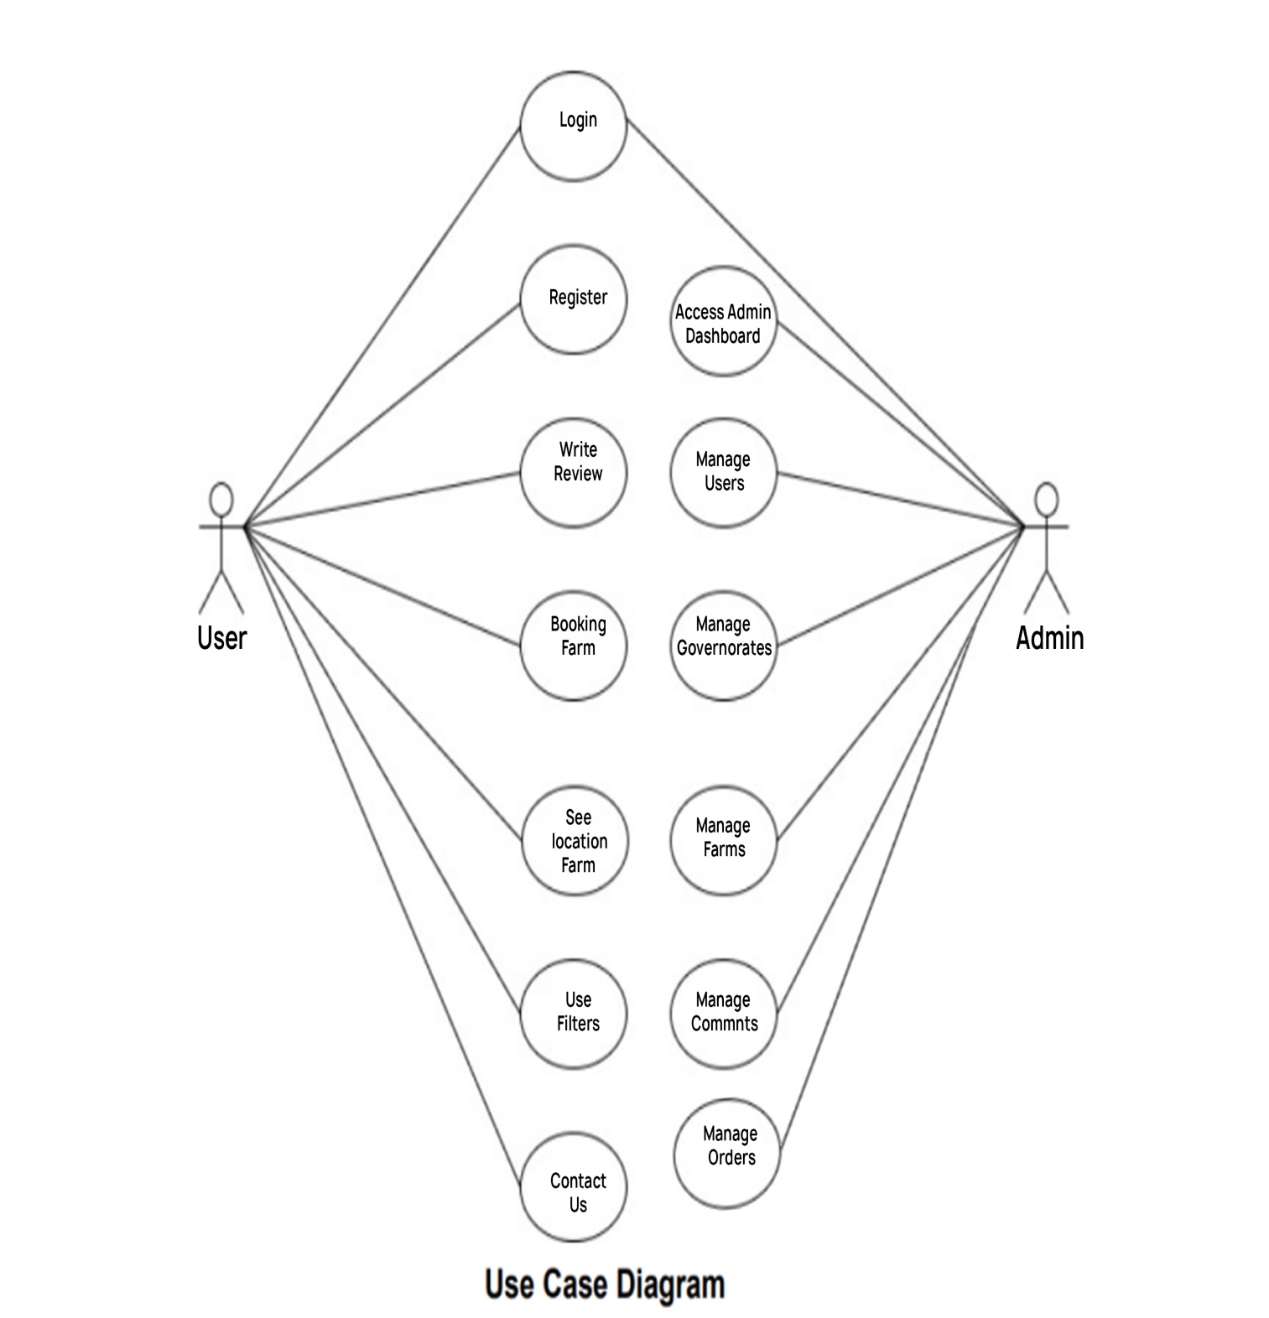

DATABASE SCHEMA

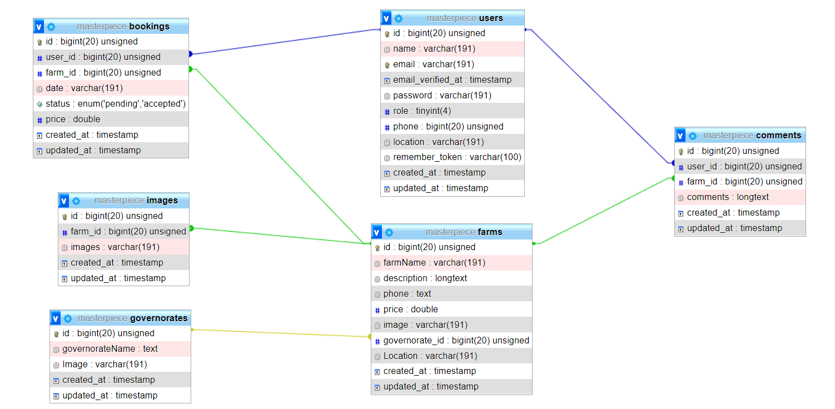

# Conclusion & Future Work

As the world is an evolving place with an ever ending need and produce of products, as this system shall keep being updated and upgraded to keep up with it. To wrap up my experience in creating and developing the MVP of the system, I have implemented most of what I self-learned in Coding Academy by Orange covering the following competencies in transpose level:

* + 1. Create mock-ups for an application
    2. Create static and adaptive web user interfaces
    3. Develop a dynamic web user interface
    4. Create a user interface with a content management or e-commerce solution
    5. Create a database
    6. Develop data access components
    7. Develop the back end of a web or mobile web application
    8. Create and implement components in a content management or e commerce application

It was a journey full of ups and downs, but thriving in general. Here are some of the lessons learned on both levels personally and professionally:

1. Planning is essential for project enrollment and success
2. Working on a personal project while newly joining a company is overwhelming yet disciplining
3. Team work is appreciated and makes all the difference yet independency is powerful
4. Full-stack development is essential to understand the full view of a web developer, personally working on this project I discovered that I am more into frontend development than backend development, even though I am better at the latter

## Future work

Believing in continuous development and the urge to keep the value of this system increasing, below is a list of the enhancements and features to be added to the website:

* + 1. Expand governorate and farms.
    2. Add Number favourite for each farms.
    3. Implement live chat for users to interact directly about farms.
    4. Eventually, if the system succeeds I will convert it to an unbiased e- commerce that connects customers and vendors